1.类student

#include<iostream>

using namespace std;

class student

{public :

char name[20];

unsigned int id;

double score;

void input( )

{ cout<<"name?"<<endl;

cin>>name;

cout<<"id?"<<endl;

cin>>id;

cout<<"score?"<<endl;

cin>>score;

};

void output( )

{

cout<<"name:"<<name<<endl;

cout<<"id:"<<id<<endl;

cout<<"score:"<<score<<endl;

};

};

int main()

{

student s;

s.input();

s.output();

}

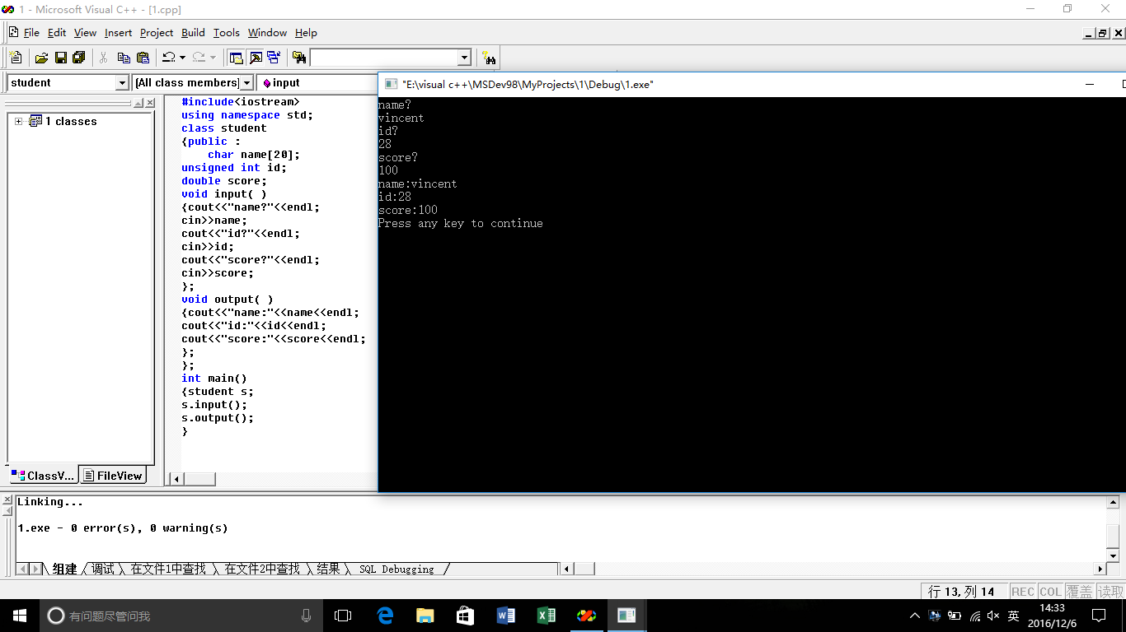

2.图书管理

#include<iostream>

using namespace std;

class Book

{

public:

char bookname[50];

double price;

int number;

void display()

{

cout<<"bookname:"<<bookname<<endl;

cout<<"price:"<<price<<endl;

cout<<"number:"<<number<<endl;

}

void borrow()

{

number=number-1;

cout<<number<<endl;

}

void restore()

{

number++;

cout<<number<<endl;

}

};

int main()

{int x;

Book tushu;

cout<<"the book's name is:"<<endl;

cin>>tushu.bookname;

cout<<"the number of the book is:"<<endl;

cin>>tushu.number;

cout<<"the price of the book is:"<<endl;

cin>>tushu.price;

tushu.display();

cout<<"if you want to borrow,input 0"<<endl;

cout<<"if you want to restore,input 1"<<endl;

cin>>x;

switch(x)

{

case 0 : {tushu.borrow();

cout<<"the number of the book is:"<<tushu.number<<endl;

};break;

case 1 : {tushu.restore();

cout<<"the number of the book is:"<<tushu.number<<endl;

};break;

default : return 0;

}

}

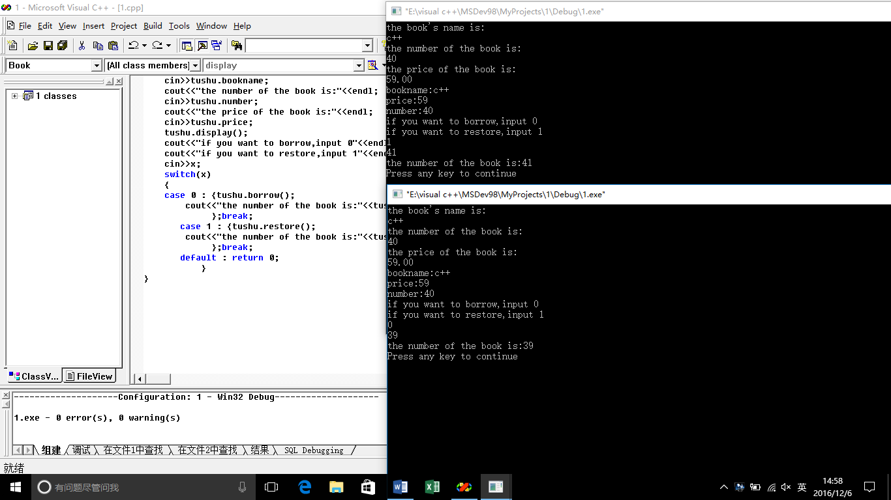

1. 学生分数

#include<iostream>

using namespace std;

class student

{

static double total;

static int count;

public:

double score[10];

void scoretotalcount()

{

cout << "student count:\n";

cin >> count;

cout << "student score:\n";

for (int i = 0; i < count;i++)

{

cin >> score[i];

}

for (int j = 0; j < count;j++)

{

total = score[j] + total;

}

}

void sum()

{

cout << "total:" << total << "\n";

}

void average()

{

cout << "average:" << (total / count);

}

};

double student::total = 0;

int student::count = 0;

int main()

{

class student stu;

stu.scoretotalcount();

stu.sum();

stu.average();

}

